**Exercise 1: Mocking and Stubbing**

**Scenario:**

You need to test a service that depends on an external API. Use Mockito to mock the

external API and stub its methods.

Steps:

1. Create a mock object for the external API.

2. Stub the methods to return predefined values.

3. Write a test case that uses the mock object.

**SOLUTION:**

MyService.java

package org.example;  
  
public class MyService {  
 private ExternalApi api;  
  
 public MyService(ExternalApi api) {  
 this.api = api;  
 }  
  
 public String fetchData() {  
 return api.getData();  
 }  
  
}

ExternalApi.java

package org.example;  
  
public interface ExternalApi {  
 String getData();  
  
}

MyServiceTest.java

package org.example;  
import org.junit.jupiter.api.Test;  
import static org.junit.jupiter.api.Assertions.*;  
import static org.mockito.Mockito.*;  
  
public class MyServiceTest {  
  
 @Test  
 public void testExternalApi() {  
 // Step 1: Create mock  
 ExternalApi mockApi = *mock*(ExternalApi.class);  
  
 // Step 2: Stub method  
 *when*(mockApi.getData()).thenReturn("Mock Data");  
  
 // Step 3: Inject mock into service  
 MyService service = new MyService(mockApi);  
  
 // Step 4: Call method and assert  
 String result = service.fetchData();  
 *assertEquals*("Mock Data", result);  
 }  
  
  
}

OUTPUT

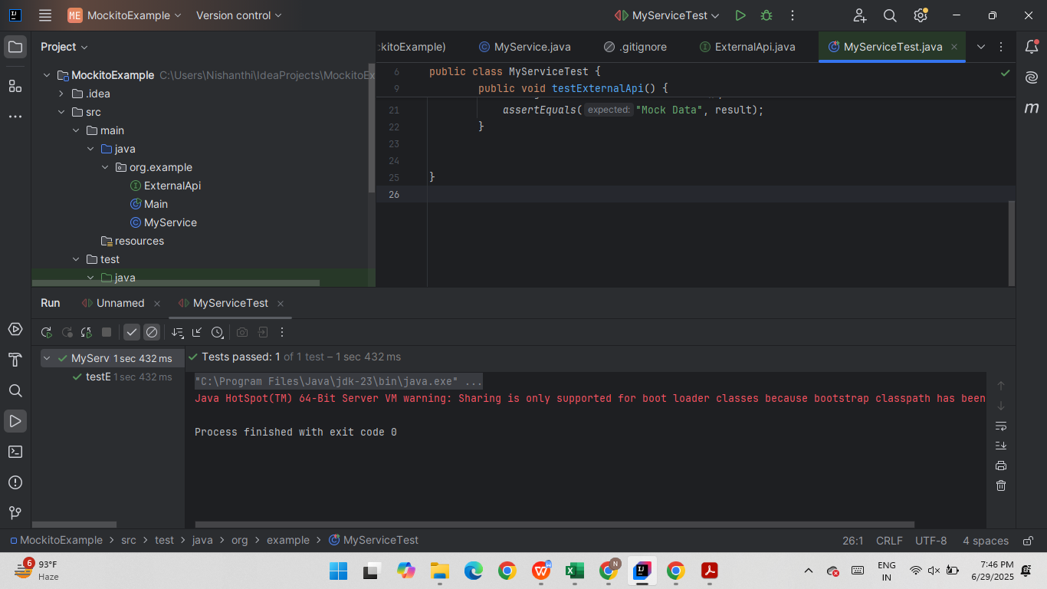

**Exercise 2: Verifying Interactions**

**Scenario:**

You need to ensure that a method is called with specific arguments.

Steps:

1. Create a mock object.

2. Call the method with specific arguments.

3. Verify the interaction.

}

**SOLUTION:**

MyService.java

package org.example;  
  
public class MyService {  
 private ExternalApi api;  
  
 public MyService(ExternalApi api) {  
 this.api = api;  
 }  
  
 public String fetchData() {  
 return api.getData(); // This call will be verified  
 }  
}

ExternalApi.java

package org.example;  
  
public interface ExternalApi {  
 String getData();  
  
}

MyServiceTest.java

package org.example;  
  
import org.junit.jupiter.api.Test;  
import static org.mockito.Mockito.*;  
  
public class MyServiceTest {  
  
 @Test  
 public void testVerifyInteraction() {  
 // Step 1: Create a mock  
 ExternalApi mockApi = *mock*(ExternalApi.class);  
  
 // Step 2: Call the method  
 MyService service = new MyService(mockApi);  
 service.fetchData();  
  
 // Step 3: Verify the interaction  
 *verify*(mockApi).getData(); // ✅ Checks that getData() was called once  
 }  
}

Output pasted in next page

OUTPUT:

